FIELD REPORT

Introduction
- Lakwatomer HC III
- Location: Lakwatomer, Omoro district
- Date of visit: 1st September 2026
1. General Observations
- The verification team met with the facility In-Charge and obtained the relevant delivery notes for the assets supplied under the UgIFT programme. The facility management was cooperative and provided access to the store and areas where the UgIFT-supported assets are currently being kept as well as used.
- The presence of UgIFT-supplied assets was physically confirmed at the facility. However, the assets could not be individually verified because they were packed and stacked together in one room due to ongoing renovation works.
- The UgIFT-supported general ward/maternity block is currently undergoing renovation. Facility management reported that the renovation is necessary due to concerns regarding the quality of the original construction.
- Due to the ongoing renovation, several assets, including delivery beds, patient screens, office chairs and drip stands, have been temporarily stored together in one room. Some of the items are stacked on top of one another and are exposed to dust and other conditions that may affect their condition over time. The current storage arrangement makes it difficult to establish the exact quantity, condition, functionality and identification details of individual assets.
- The assets observed were generally present at the facility, but their proper placement and installation will only be possible after completion of the renovation works.

2. Special Notes
- Although the presence of UgIFT assets was confirmed, a complete physical verification could not be conducted because the items were packed together in a temporary storage area. Individual asset identification, counting and assessment of condition should therefore be undertaken once the renovation is completed.
- The facility reported concerns regarding the quality of the original UgIFT-supported construction. The ward/block is currently undergoing renovation to address the reported construction deficiencies.
- The temporary storage arrangement exposes the assets to dust, potential rust and physical damage, particularly where equipment is stacked on top of one another. Prolonged storage under these conditions may also affect the functionality and lifespan of the equipment.
- The responsible contractor should be required to address the identified construction defects and ensure that the renovation is completed to the required standards and specifications.
- A follow-up verification should be conducted after completion of the renovation to confirm the condition, functionality, installation and proper use of all UgIFT-supported assets.

The table below illustrates some physical status of the verified assets with photographic evidence.
Table XXX: Physical verification photos

LAKWATOMER HC III SIGN POST | 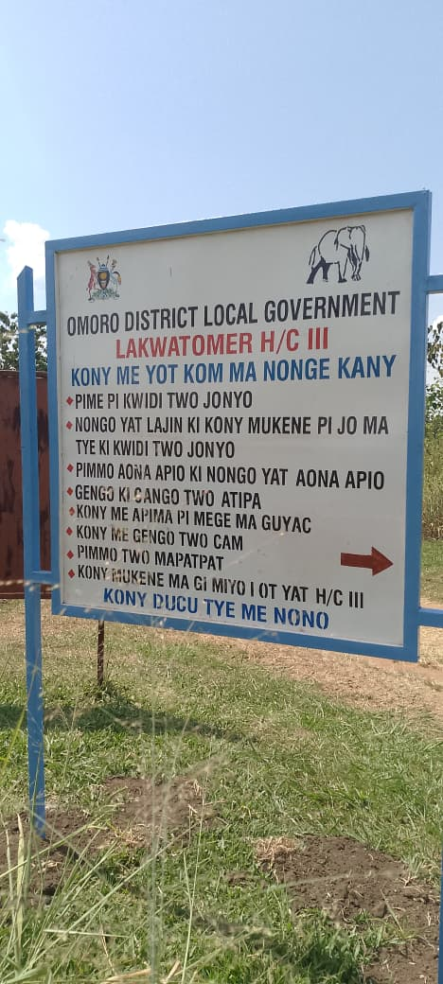
MATERNITY BLOCK (FRONT VIEW) | 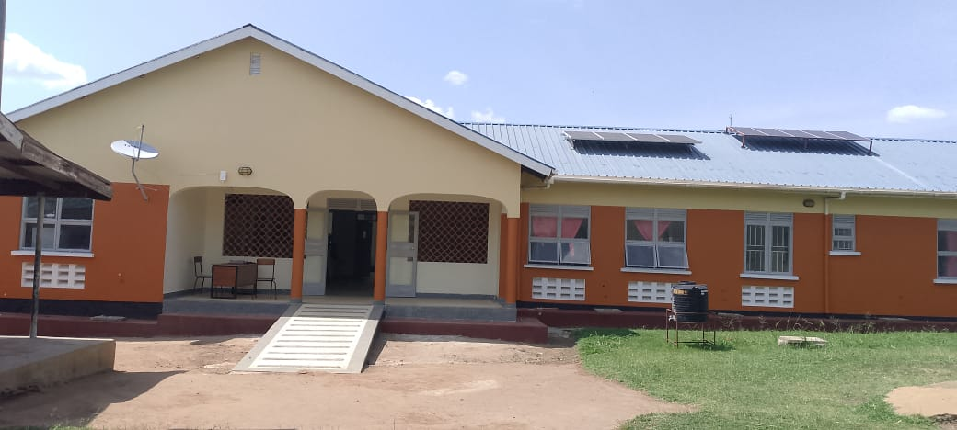
MATERITY BLOCK (SIDE VIEW) | 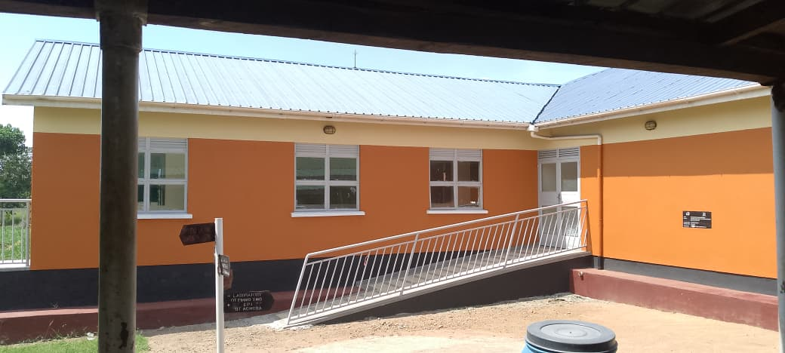
SAMPLE OF DESKS DELIVERED | 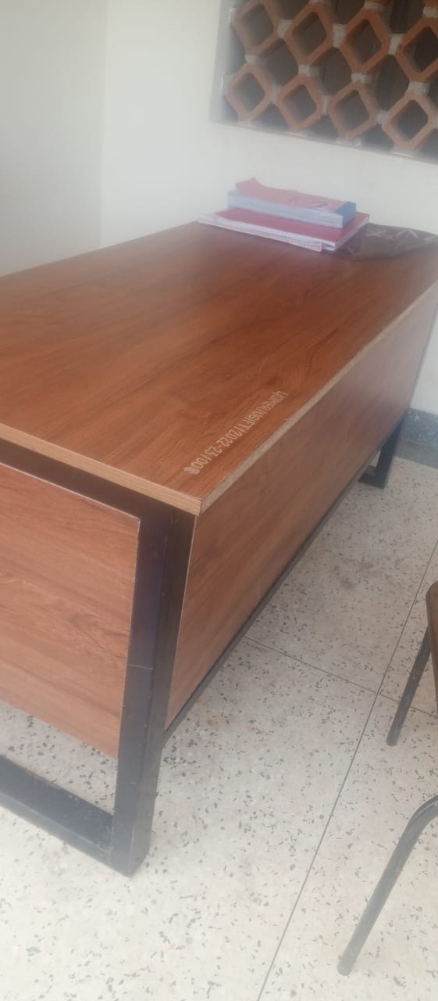
SAMPLE OF UGIFT ASSET ENGRAVING (FILING CABINET) | 